Hotels near the venue:
- Holiday Inn Bologna-Fiera (3 stars hotel)
https://www.holidayinn.com/hotels/it/it/bologna/blqfa/hoteldetail?fromRedirect=true&qSrt=sBR&qIta=99609344&icdv=99609344&glat=SEAR&qSlH=BLQFA&setPMCookies=true&qSHBrC=HI&qDest=Via%20Del%20Commercio%20Associato%203,%20Bologna,%20IT&dp=true&gclid=Cj0KCQjwuZDtBRDvARIsAPXFx3C0DHEPbbR2Bj-ZU0o0Ht1JwddJVsBaCZZCcbzd_GTV8rJIe64I8XIaAim6EALw_wcB&cid=8499&srb_u=1

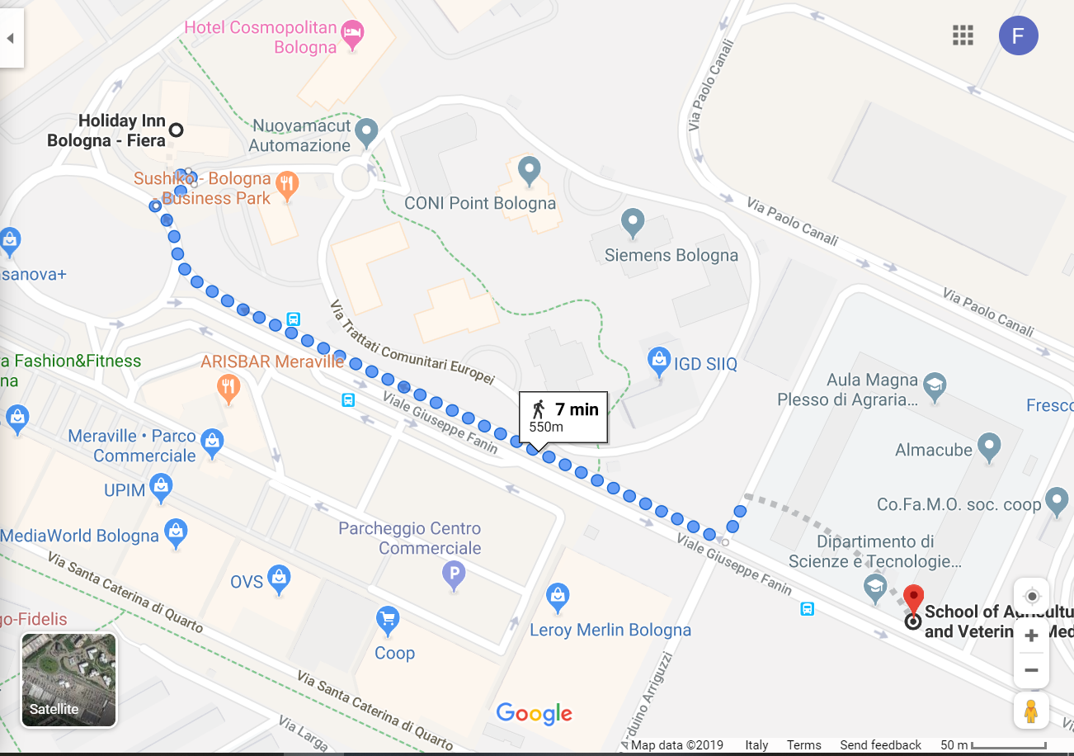

Google Maps: https://www.google.com/maps/dir/Holiday+Inn+Bologna+-+Fiera,+Via+del+Commercio+Associato,+3,+40127+Bologna+BO/Dipartimento+di+Scienze+e+Tecnologie+Agro-Alimentari+(DISTAL),+Viale+Giuseppe+Fanin,+Bologna,+BO/@44.5149755,11.4015257,17z/data=!3m1!4b1!4m14!4m13!1m5!1m1!1s0x477e2c96100c6a9f:0xb94fb9f29ae0a7ac!2m2!1d11.4006057!2d44.5164936!1m5!1m1!1s0x477e2c908b233447:0xfafddedf77fda2f0!2m2!1d11.4069993!2d44.5134574!3e2
- Cosmpolitan Bologna (4 stars hotel)
Shuttle bus service to the city Center at fixed time schedules, reservation requred (5 euros, return; 3 euros, one way)
https://www.hotelcosmopolitanbologna.com/?gclid=Cj0KCQjwuZDtBRDvARIsAPXFx3B1asroy6rafPPmjqB8RezLrmUUKFphQoDBGarYDn6QObKTnmo_pRYaAp2SEALw_wcB

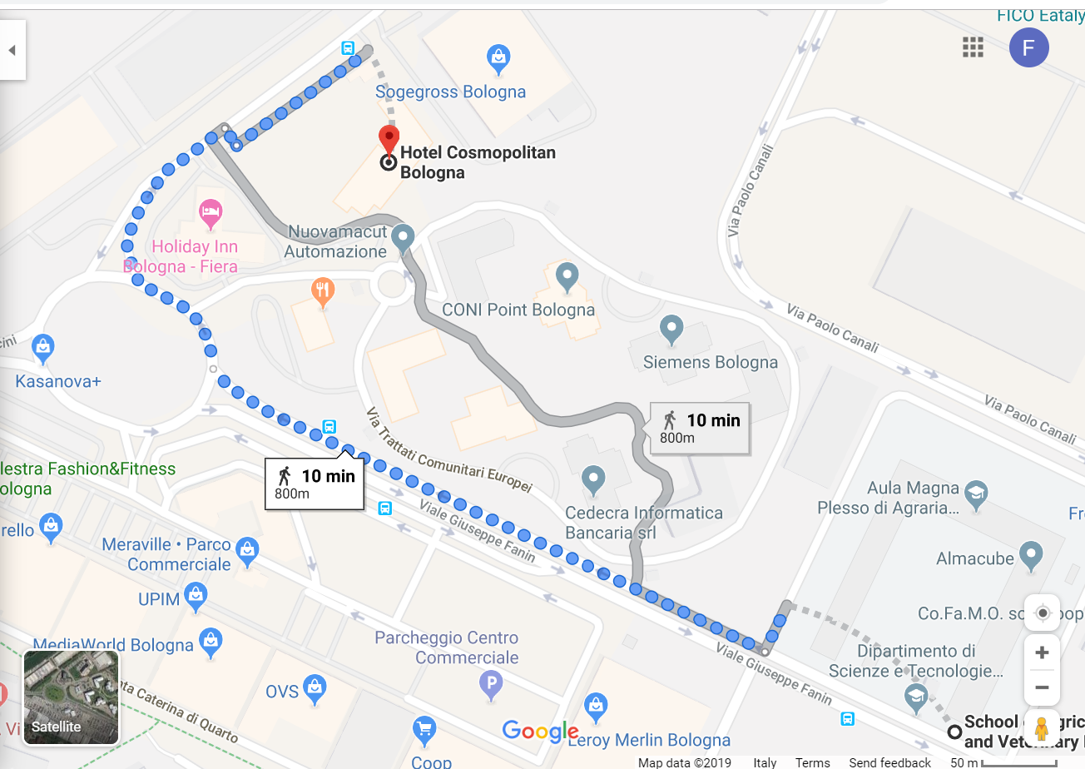
Google Maps: https://www.google.com/maps/dir/Dipartimento+di+Scienze+e+Tecnologie+Agro-Alimentari+(DISTAL),+Viale+Giuseppe+Fanin,+Bologna,+BO/Hotel+Cosmopolitan+Bologna,+Via+del+Commercio+Associato,+9,+40127+Bologna+BO/@44.5155463,11.4012537,17z/data=!3m1!4b1!4m14!4m13!1m5!1m1!1s0x477e2c908b233447:0xfafddedf77fda2f0!2m2!1d11.4069993!2d44.5134574!1m5!1m1!1s0x477e2c95df617425:0xf84bafa053fb9944!2m2!1d11.4021361!2d44.5169473!3e2

Hotels near the Railway Station:
BUS LINE 35: the bus stop is in front of the train station main entrance (PIAZZA MEDAGLIE D`ORO (PENSILINA A) SEE BELOW) . Bus direction FACOLTA’ di AGRARIA. The run it takes about 30 minutes. See the files. Ticket pay cash on board 2 euro.

- Millen Hotel (3 stars hotel)
https://www.millennhotelbologna.it/
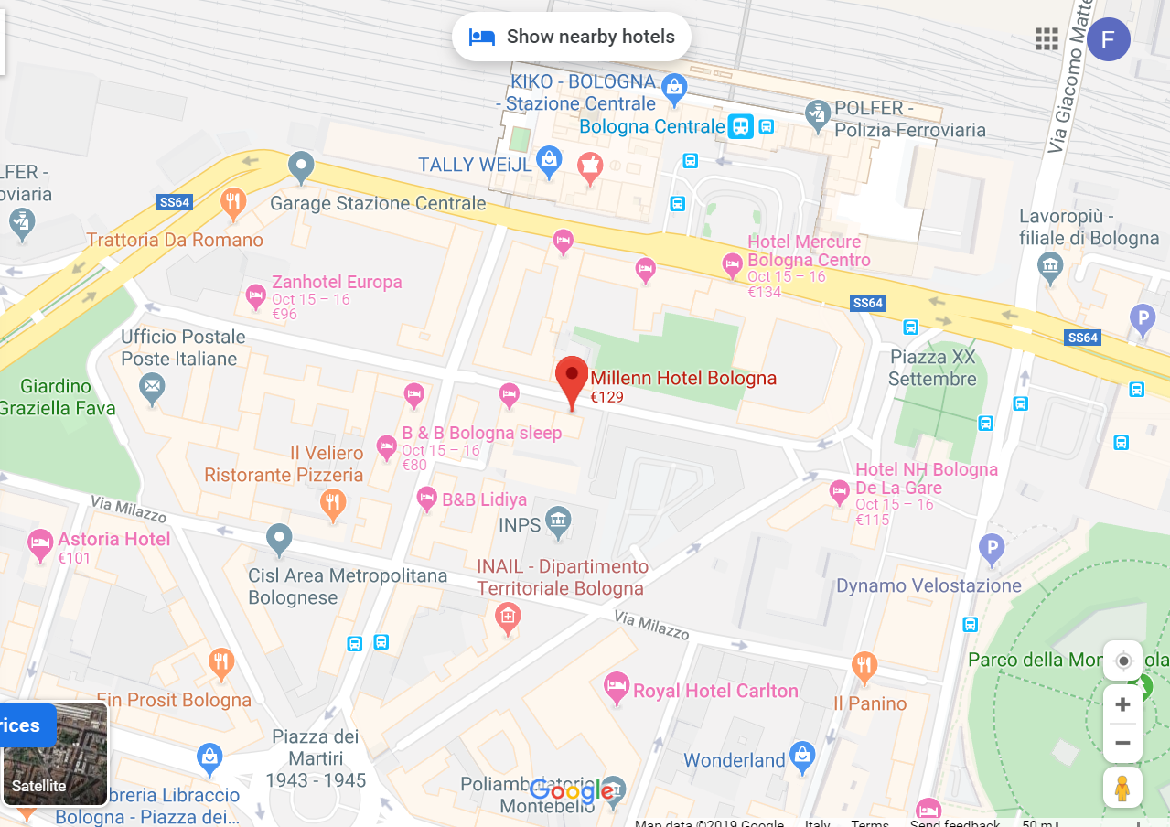
Google Maps: https://www.google.com/maps/place/Millenn+Hotel+Bologna/@44.504288,11.3397803,17z/data=!3m1!4b1!4m8!3m7!1s0x477fd4995ba8c8b1:0xba0fe191a814b040!5m2!4m1!1i2!8m2!3d44.504288!4d11.341969

- Nuovo Hotel del Porto (3 stars hotel)
http://www.nuovohoteldelporto.com/en/

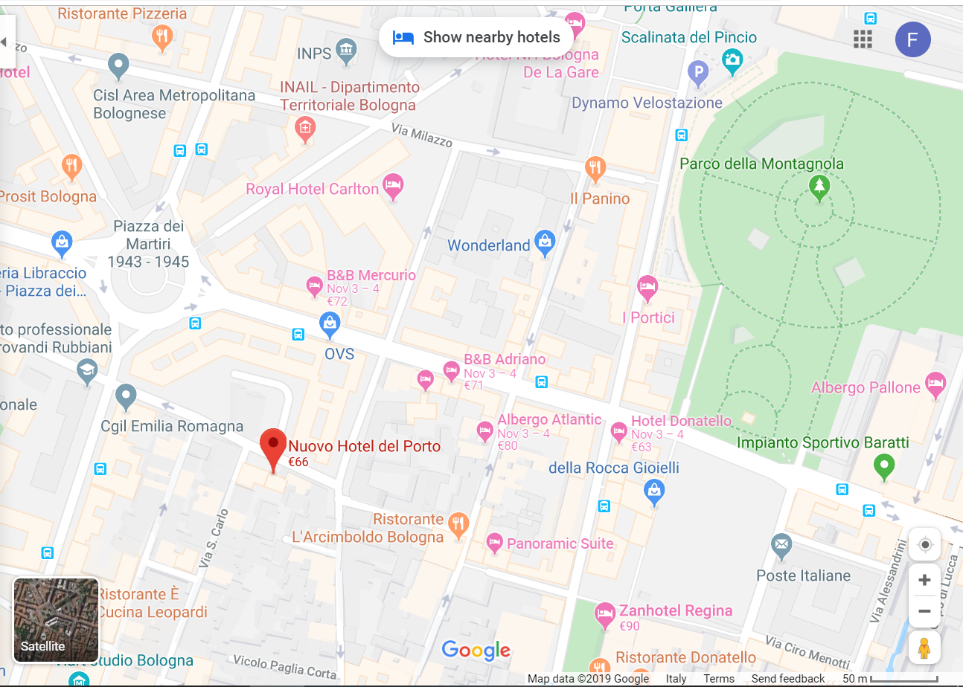
Google Maps: https://www.google.com/maps/place/Nuovo+Hotel+del+Porto/@44.5016791,11.3409284,17z/data=!4m8!3m7!1s0x477fd499e6ed18cf:0xffb3f650d1c6ead8!5m2!4m1!1i2!8m2!3d44.5007762!4d11.3411644

- Hotel Atlantic Bologna (3 stars hotel)
http://www.hotelatlanticbologna.it/

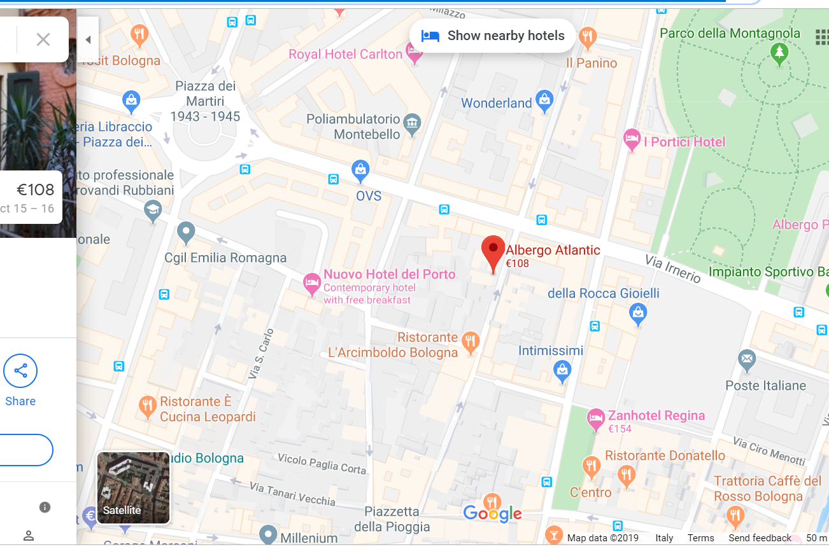
Google Maps: https://www.google.com/maps/place/Albergo+Atlantic/@44.5009776,11.3410077,17z/data=!3m1!4b1!4m8!3m7!1s0x477fd4982d859dc1:0x4dc82b432be50e6a!5m2!4m1!1i2!8m2!3d44.5009738!4d11.3431964

- Star Hotel Excelsior (4 stars hotel)
https://www.starhotels.com/it/i-nostri-hotel/excelsior-bologna/offerte/advance-booking.html?gclid=Cj0KCQjwuZDtBRDvARIsAPXFx3AJ-CuzLAJLIg0QOA1pSMBf7mr1jE4yeHWmpVvaFjfGdpVtTpWR054aAhZVEALw_wcB
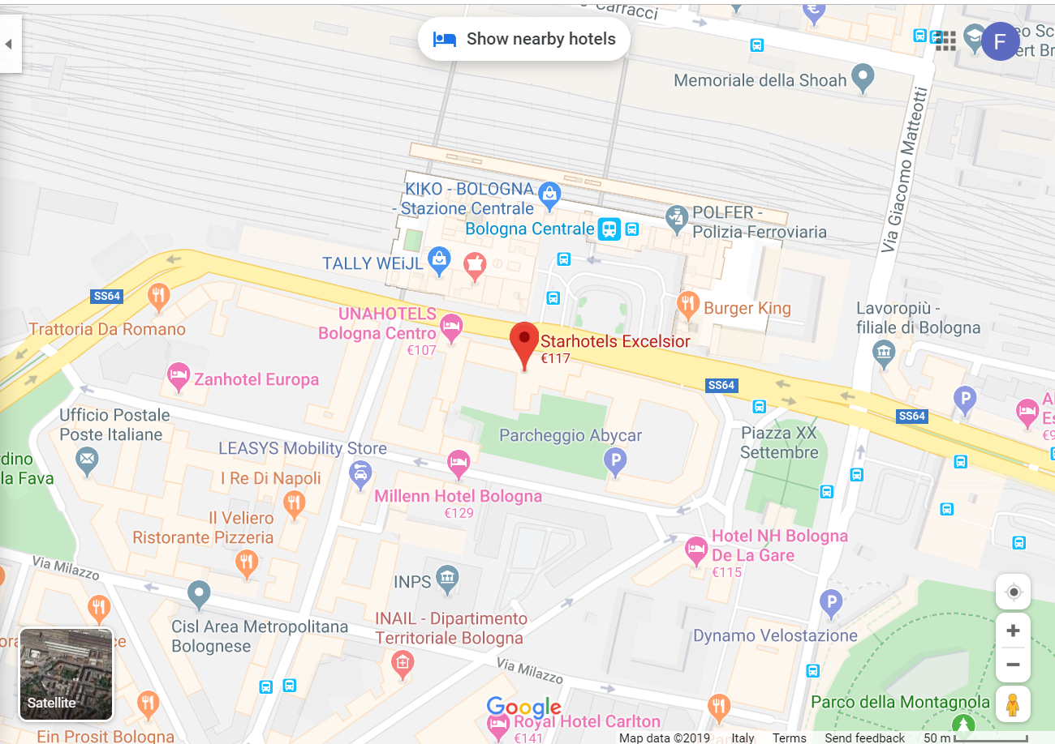
Google Maps: https://www.google.com/maps/place/Starhotels+Excelsior/@44.504983,11.3403563,17z/data=!3m1!4b1!4m8!3m7!1s0x477fd49ead95dd27:0x300d2f57701d3945!5m2!4m1!1i2!8m2!3d44.504983!4d11.342545
Airbnb:
https://it.airbnb.com/a/Bologna--Italy?af=43720035&c=.pi0.pk62676087331_280718960066_c_64350000093&gclid=Cj0KCQjwuZDtBRDvARIsAPXFx3DzC8iPX8ZS1G8NhtusPUHuhYCfgQ7c9Cyk4yWKkuGoMNVt2bt75_0aAgOYEALw_wcB&location_of_interest=&location_physical=1008141&sem_position=1t1&sem_target=kwd-64350000093

